Assignment 15.1

1. Write a simple program to show inheritance in Scala.

Step1: Defined Class person

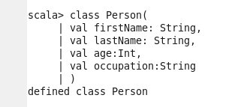

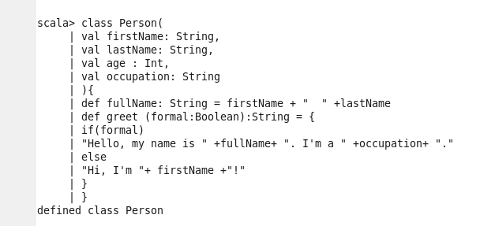

Step2: Defined Class Linguist

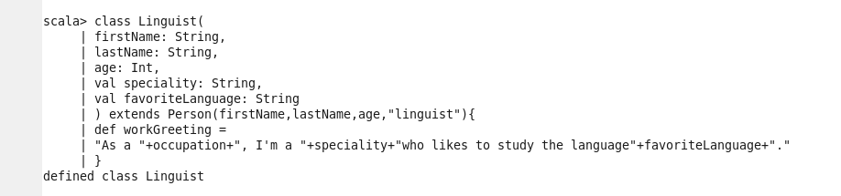

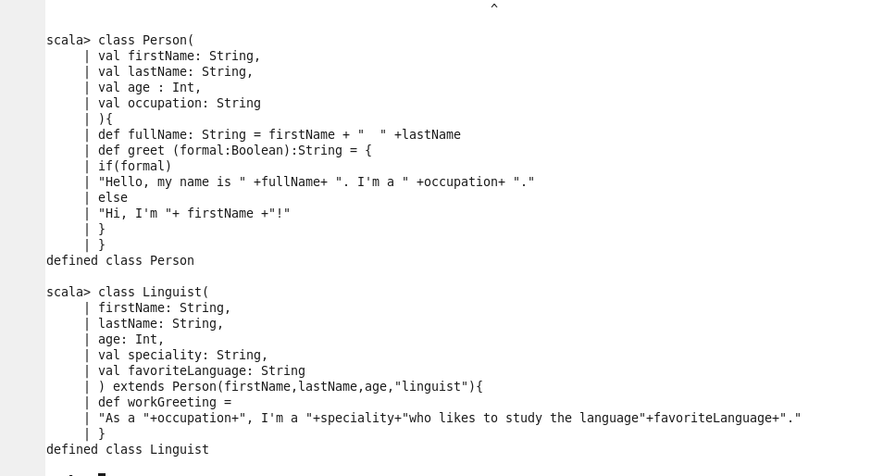

Step3: passing values to variables defined in above two class

Step4: printing data / text of a function defined in class ‘Linguist’

Step5: Printing ‘age’ of a person
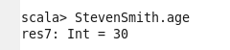

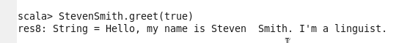

Step6: Printing ‘favorite language of a person
